Reading Tasks:

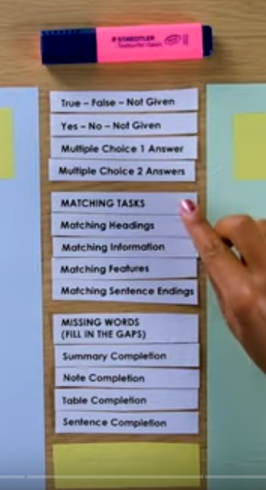

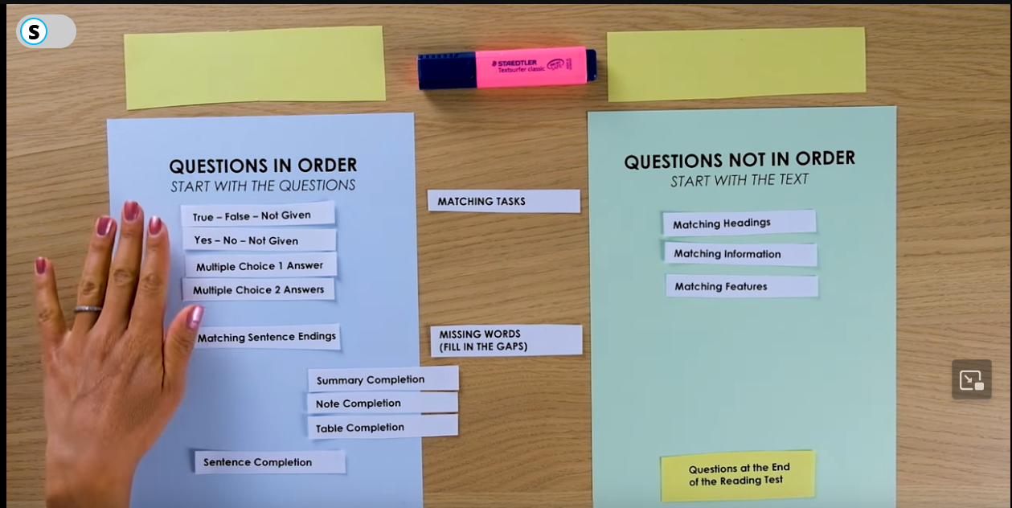

True False Not Given Questions:

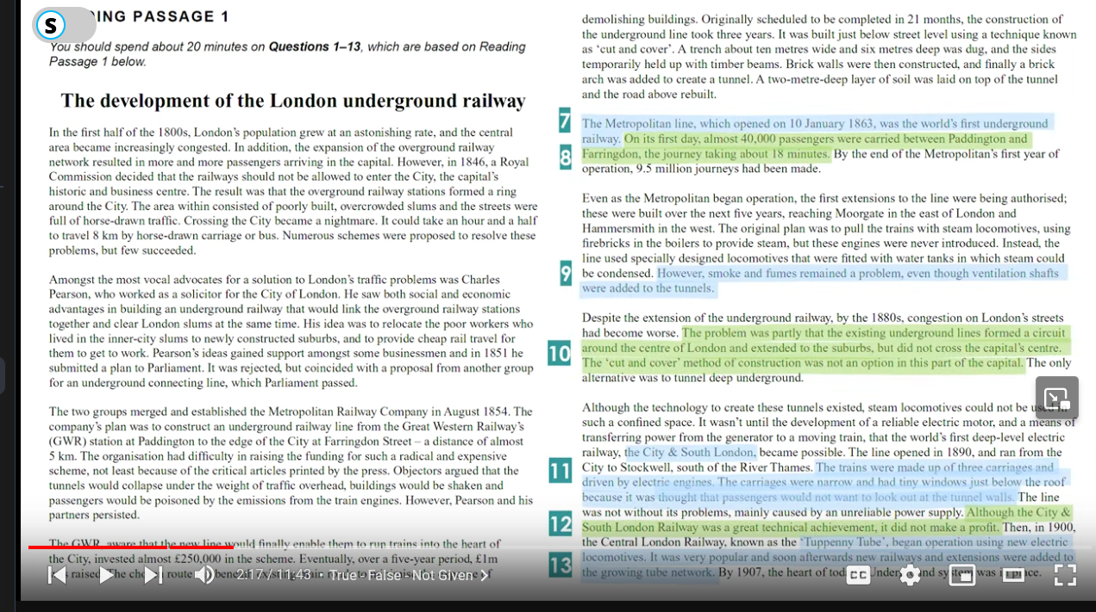

Yes – No – Not Given:

* More about opinions and less about facts
* We need fully understand someone’s opinion

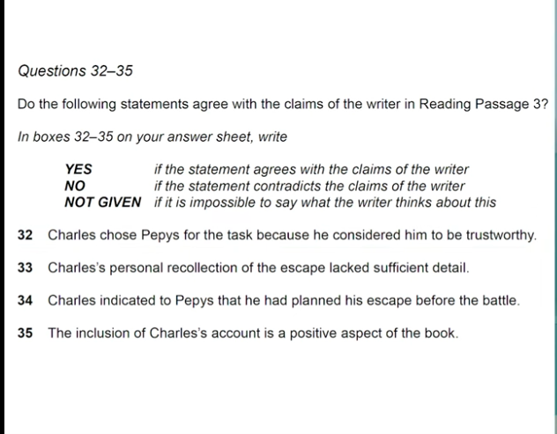

Multiple Choice Questions:

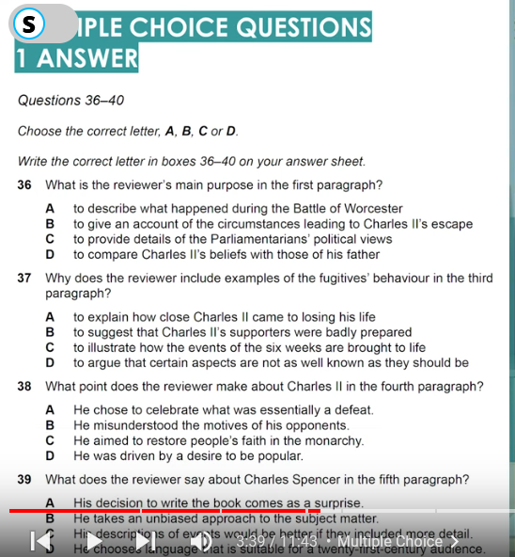

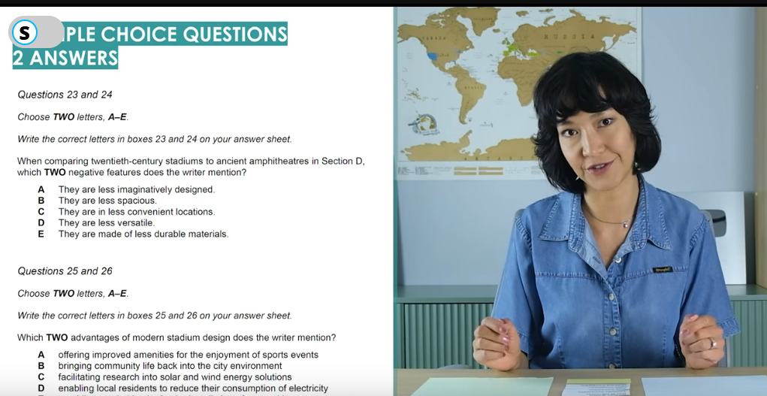

Matching Headings:

Read the paragraph and then start match the headings as this is unordered.

Do this in 1 go and then start matching those paragraphs you couldn’t match.

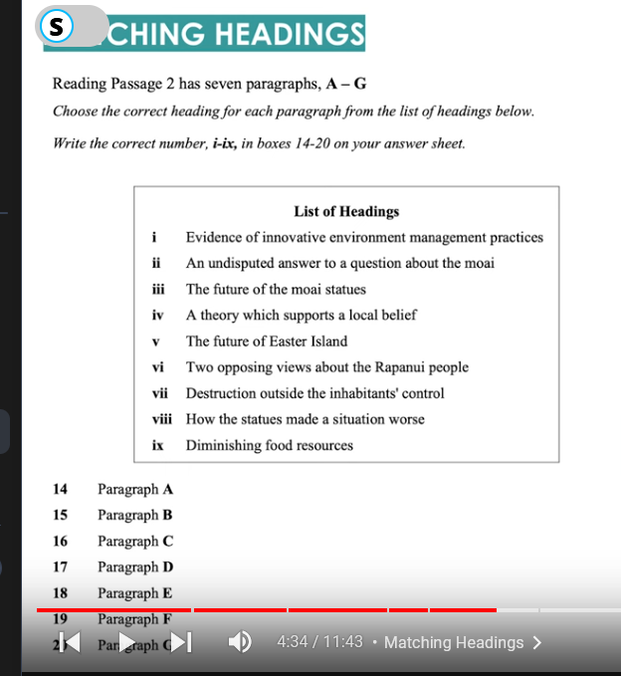

Matching Information:

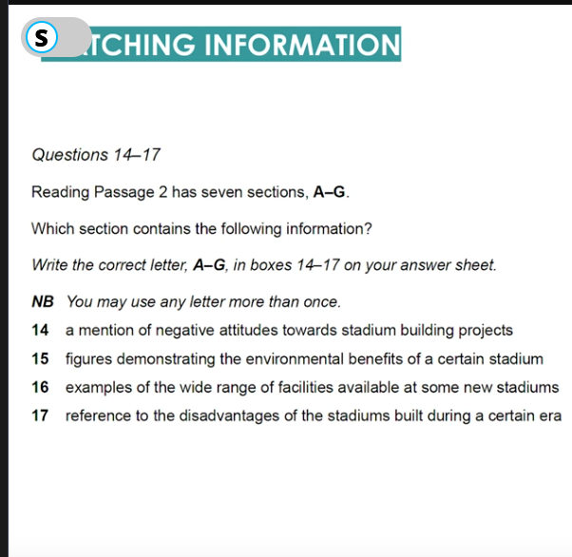

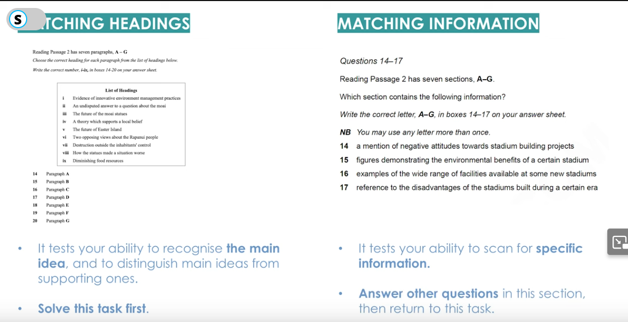

Matching Features:

* First highlight the listed features quickly and then bind the features.

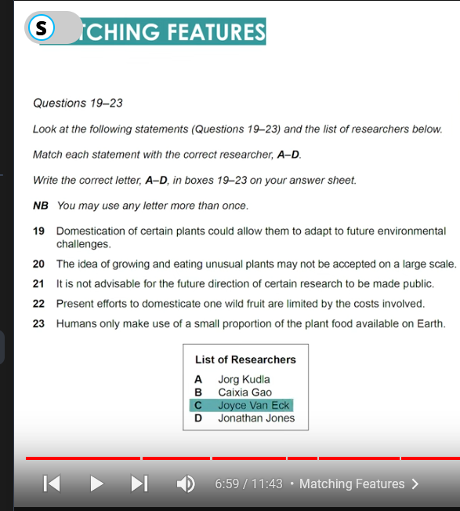

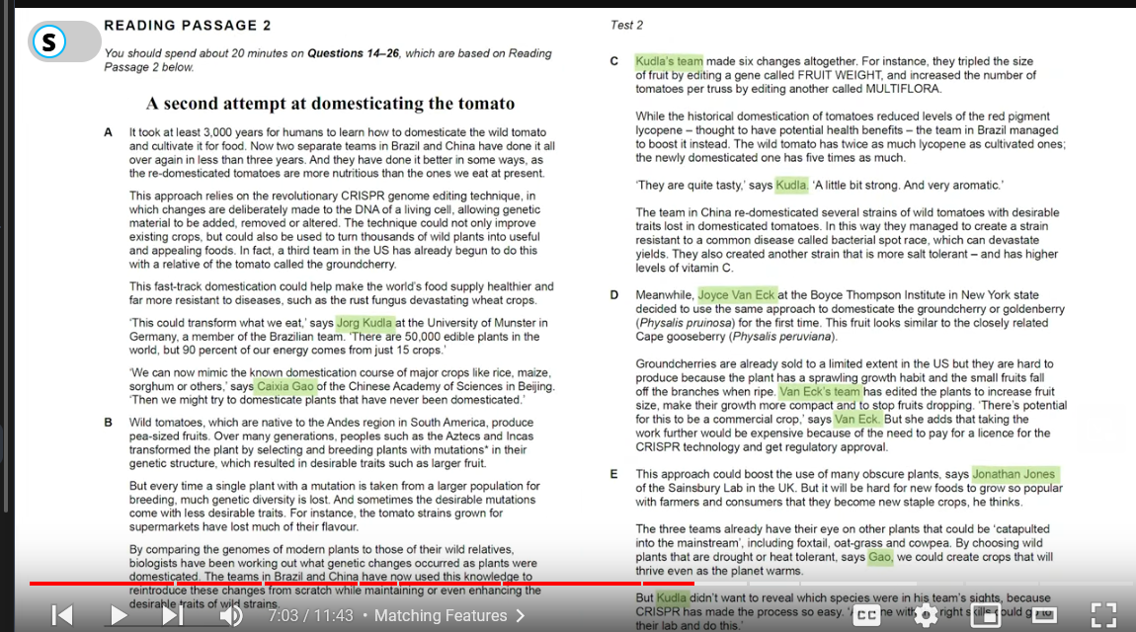

Matching Endings:

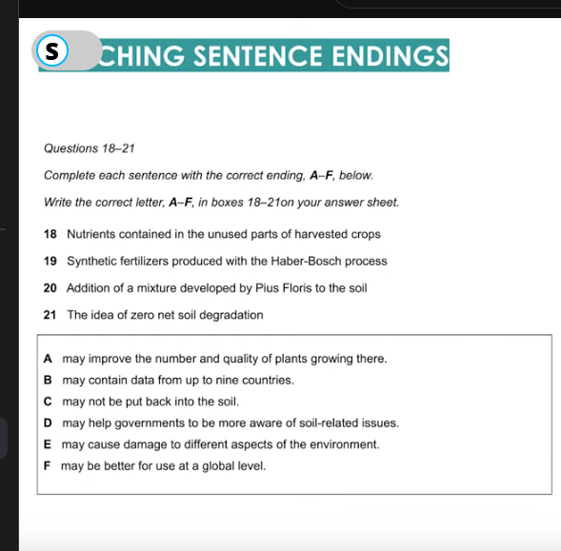

Summary/Note/Table Completion:

Can or Cannot occur in order but most of them do come in order.

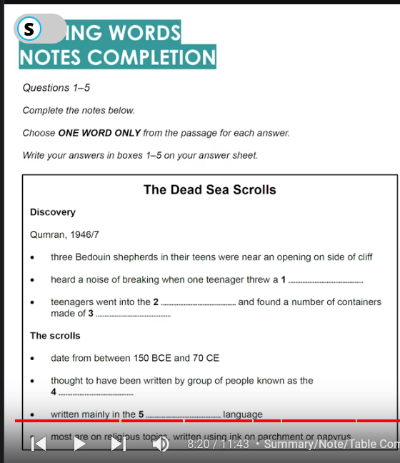

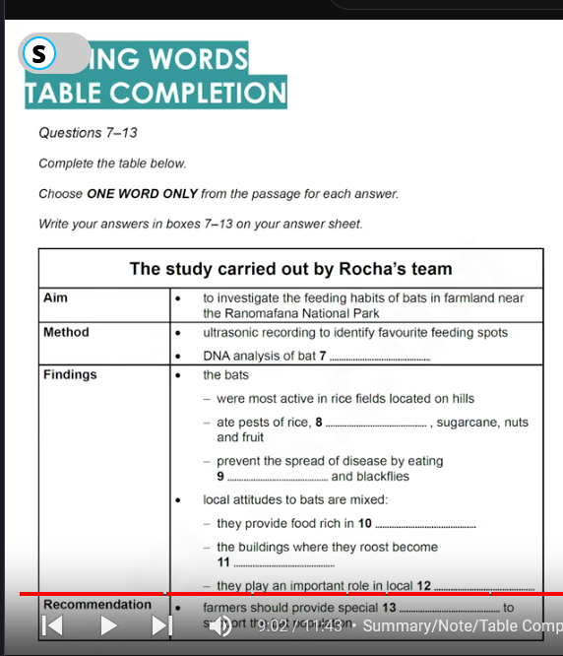

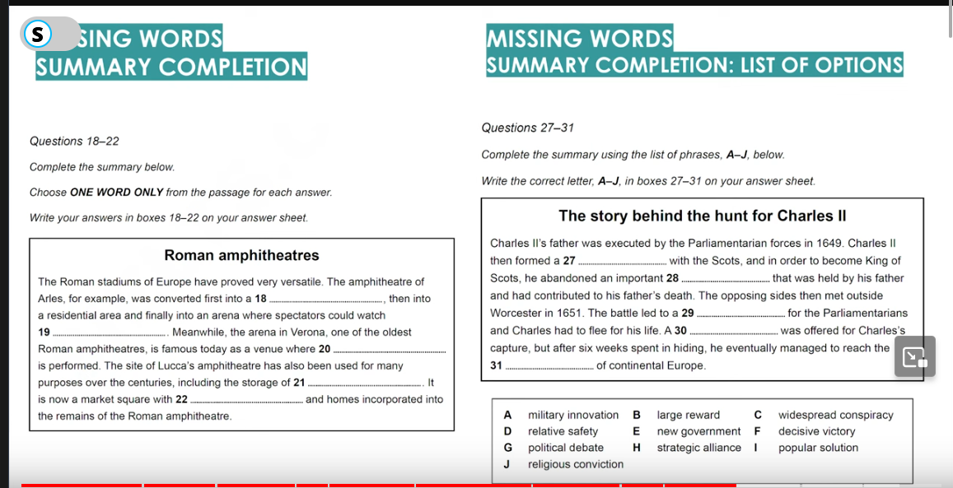

Sentence Completion:

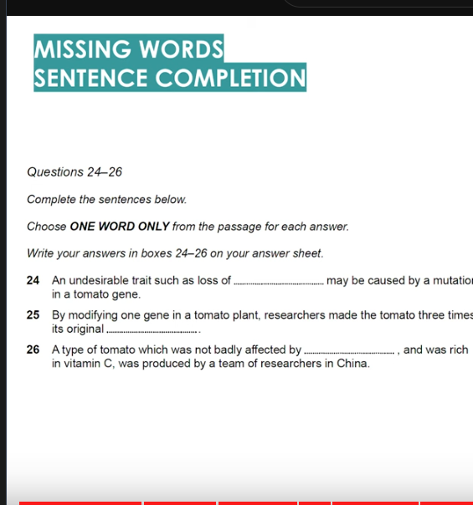

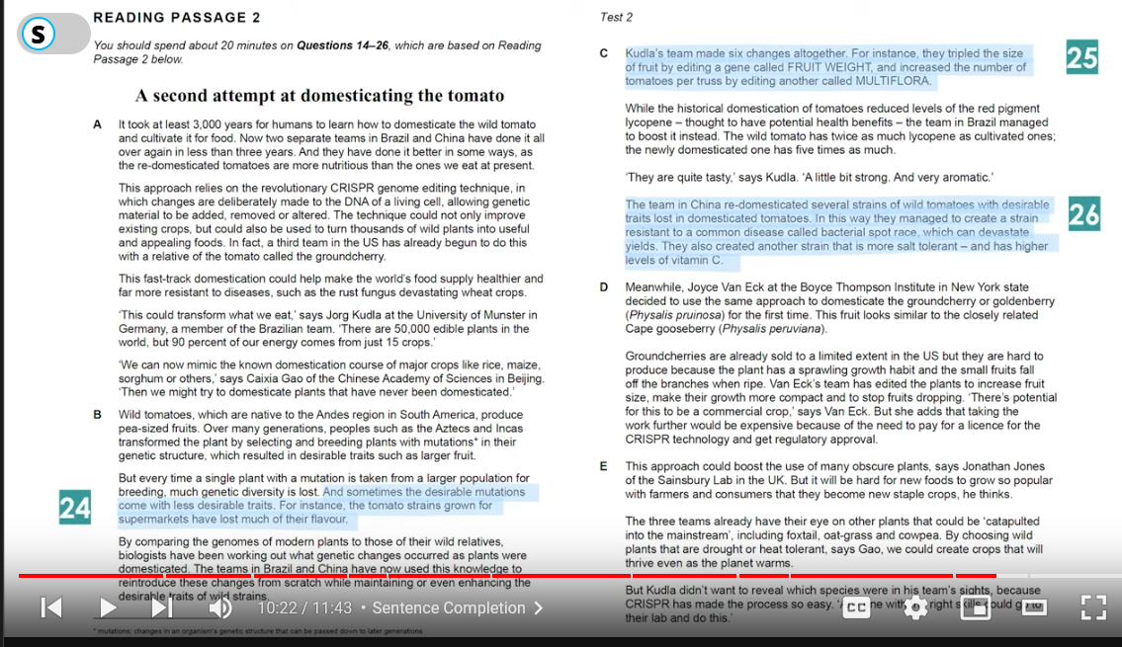

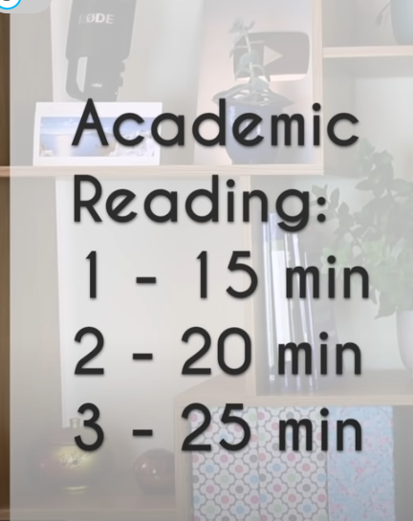

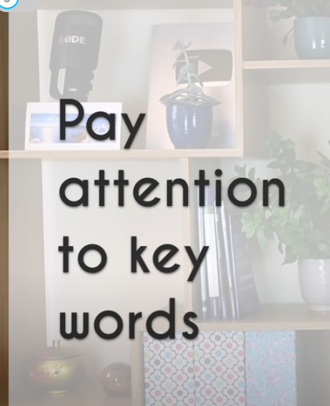

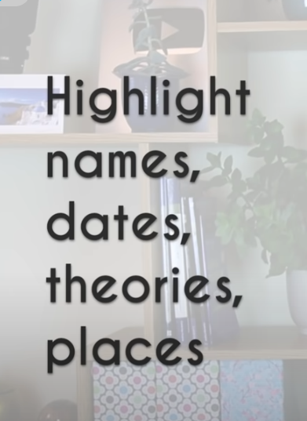

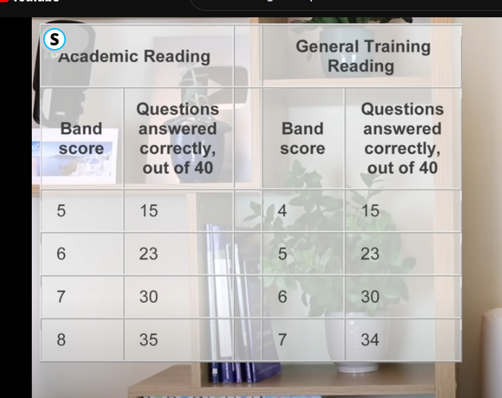

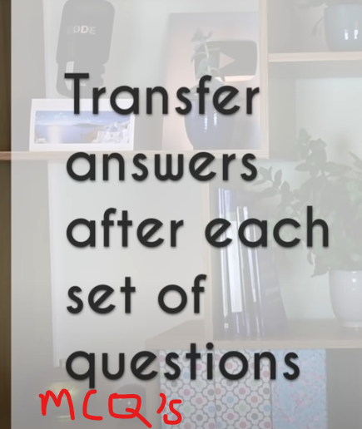

* 40 questions -> 3 longer
* I would say Read x3 questions first then start skimmsing through the paragraphs and when you feel you reached a point where the answer is somewhere hidden its time to slow down the pace.
* Read the question and highlight the keywords and what do they mean, look for the keywords synonyms in the paragraph
* Ignore irrelevant content that doesn’t relate with the keywords
* Most of the questions order follow the passage

True – False – Not Given

* There must be all 3 types of answers used in this exam

